**Simple Security System in Assembly**

**Yousif Abudieh 20210762**

In this project, I implemented a simple security system using Assembly 8086.

First, A welcome message is displayed to the user, then the user is asked to enter the username.

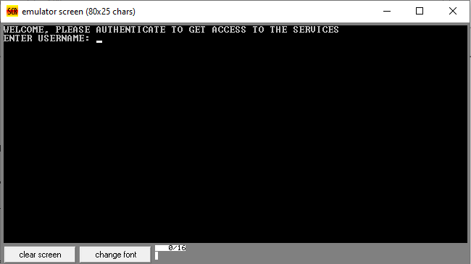

If the user enters a non-existing username or a username with more than 8 characters, an appropriate error message is displayed and the program stops.

Examples:

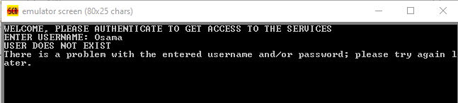

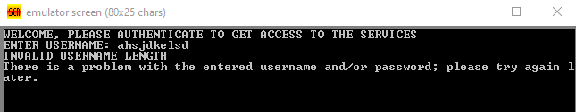

If the user successfully enters a valid username, then he/she is asked to enter the password associated with that username.

If the password entered contains more than 16 characters or is incorrect, an appropriate error message is displayed and the program stops.

Examples:

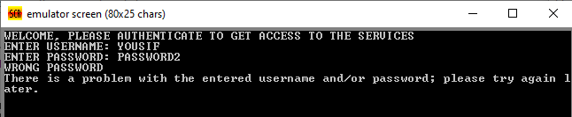

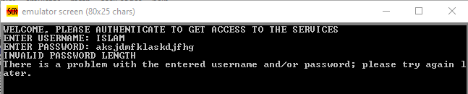

These are the usernames with their passwords (USER1’s password is PASS1, USER2’s password is PASS2 and so on):-

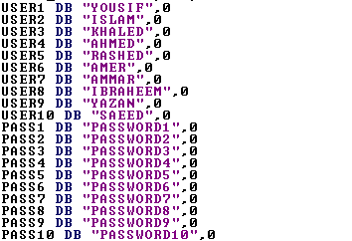

If the user successfully authenticates, the program moves on to the Data Encryption Module.

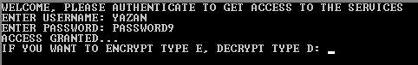

The user is now asked to enter E or D depending on the service they wish to get.

If the user Enters another character, they are asked to re-enter a character until a valid character is entered.

Then they are asked to enter the encryption key.

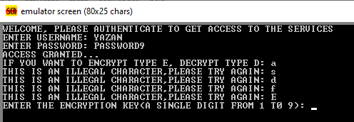

After entering the key, they are asked to input a message, if they reach 20 characters, then the program will pause, store 0DH in location 3116H, encrypt the 20 characters and display the output, this makes it impossible for the user to enter more than 20 characters.

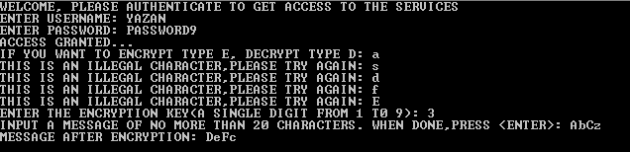

The same thing happens with decryption. The only difference between them is the process of encrypting/decrypting.